About the Peninsula Foundation
The Peninsula Foundation, formed in 1997, is a non-profit 501c (3) operating foundation whose charitable mission is to preserve the heritage, maintain the character and promote the vitality of Peninsula, Boston Township and the Cuyahoga Valley by engaging the community though art, entertainment programming and historic preservation. This mission is compatible with the goals and purposes of the Village of Peninsula’s Long Range Plan. Further, a documented priority within the Foundation’s Business Plan is to ensure that the preservation of historic architecture, and use of the Foundation’s historic properties, aligns with and supports this mission.

Request for Proposals
The Peninsula Foundation seeks partners for the use and development of numerous properties owned by the Foundation in the Village of Peninsula. The Foundation is very focused upon retaining the historic canal-era character and charm of the Village, which to-date has avoided the destructive impacts of template commercialization and over-development which has eroded or destroyed the essential character of so many towns and villages. Peninsula is very fortunate to be home to three very special assets which bring hundreds of thousands of annual visitors to Peninsula and help define the unique character of the community:
- The Cuyahoga Valley National Park (CVNP), with the hugely popular Ohio & Erie Canal Towpath traversing the heart of the Village.
  - Recognizing the impact of the Park, the Peninsula Village Council recently designated the village as a “Gateway Community” to the National Park.
- The Cuyahoga River, which runs through the center of the Village and is just beginning to be discovered by large numbers of kayakers and canoeists.
  - The river is considered clean most days of the year.
  - In the future large numbers of boaters are expected to use Peninsula as a put-in and take-out location for their trips on the river.
- The Cuyahoga Valley Scenic Railroad, with its tremendously active Peninsula Station in the heart of the Village.

Coupled with two very popular restaurants, bike rental shops, a National Park gift shop, and other small commercial establishments, Peninsula has become a magnet for tourism. The Foundation’s “Voices in the Valley” series also brings nationally recognized musical acts and cultural programs to the historic GAR Hall in the heart of the Village, with over 140 concerts and other programs each year.
In addition, the Peninsula Foundation owns 14 commercial properties in the Village which give it considerable control over future development in the community.
It is through this RFP that the Foundation hopes to find development partners in shaping the future financial and aesthetic character of our beloved community.
There are seven properties included in the Properties Offered section of this offering. A respondent to this RFP may submit proposals:
- For a single property or for multiple properties.
- Multiple property proposals should make clear whether individual properties are to be considered separately as stand-alone proposals or whether multiple properties are to be considered only as a group proposal or some combination.
The business relationship between the Foundation and the partner may vary in any proposal and property by property. The Foundation will consider varied business arrangements:
- Simple landlord/tenant arrangement.
- Sale of a property to a party for an agreed-upon price and specific development plan.
- Equity partner concepts.
- Tenant build-out proposals with a long-term lease.
- Other partnership arrangements which respond to the Foundation’s need to leverage funding for capital expenses in buildings requiring rehabilitation or in new site development.

Water/Wastewater Services
Proposers should be aware that the Village of Peninsula is working towards having municipal sewer and water service developed for the central area of the Village, including service to all the properties offered in this RFP. While no specific date has yet been determined for the completion of these projects, it is estimated that their completion will be accomplished by the end of 2026. The Foundation (or other owner, if sold) will be responsible for the cost of connecting to these services including possibly decommissioning existing infrastructure. Proposers should contact the Foundation regarding wastewater and potable water systems currently in use in offered properties. Upgrades may be required depending on proposed uses.

Zoning/Planning Activities
The Village of Peninsula is about to embark on a Master Planning exercise to better define the types of development that are desired for the community, and to update the Zoning Ordinances accordingly. Some zoning codes are likely to change through this process.

Project Goals
- Plans are in harmony with Peninsula’s Long Range Plan and follow current Zoning Ordinances. Proposals for second floor residential units or residential use of accessory buildings in Commercial Districts are desired by the Foundation but will be subject to approval by the Village of Peninsula.
- Develop buildings in a manner sympathetic to the character and size of surrounding buildings and in the community, interior and exterior.
- Develop buildings with an eye towards the appearance, design, roof form, massing, and scale of historic buildings in the community.
- Develop the first floor of buildings as storefronts, with a tenant(s) providing services to Village residents and community visitors.
- Develop residential unit(s) in the second story of properties, where feasible, emphasizing smaller, one- and two-bedroom residential unit(s).
- Second story office uses are also acceptable.
- Promote business tenancy that offers products and services by local makers, artisans and artists, if feasible.
- Do not allow chain store retail or service tenancy, excepting small, local businesses in service of residents or visitors (e.g., regional chains like Century Cycles or Winking Lizard are acceptable).
- Follow Best Practices in walkable urban design, including locating buildings close to the street, parking located out of sight behind buildings, and generous windows in shop storefronts.
- Provide attractive streetscapes and site landscaping which encourage pedestrian access and comfort.
- Provide facilities that are ADA accessible and compliant.
- Utilize “dark sky” lighting fixtures.
- Utilize signage that is properly scaled and designed for use in an historic district.
- Utilize “green” construction materials, technology, and techniques as much as possible.

Properties Offered
- 1601 West Mill Street - MBA Building
- 1594 Main Street - DMT Property
- Riverview Court Properties
  - 1770 Main Street - Riverview Court North
  - 1770 Main Street - Riverview Court South
  - 1764 Main Street - Bigelow House
- 1599 Main St. - Nestico House
- 6084 North Locust St - Zolyniak House

1601 West Mill Street - MBA Building
Summit County parcel: 11-00054
Zoned: Commercial Square Footage: Year Built: 1961
Wastewater: Currently connected to the Peninsula Foundation wastewater plant.
Water: Shared hauled water system with neighboring property (Freight Building/Purple Brown Store).
Current status: MBA Design currently renting on month-to-month lease. Listed as non-contributing on the National Historic Register Peninsula Nomination.
Desired Outcome: 1 or 2 story building offering retail/commercial services for residents and visitors. Provide second floor residential unit(s) if feasible. Existing building may be demolished or adapted for development.

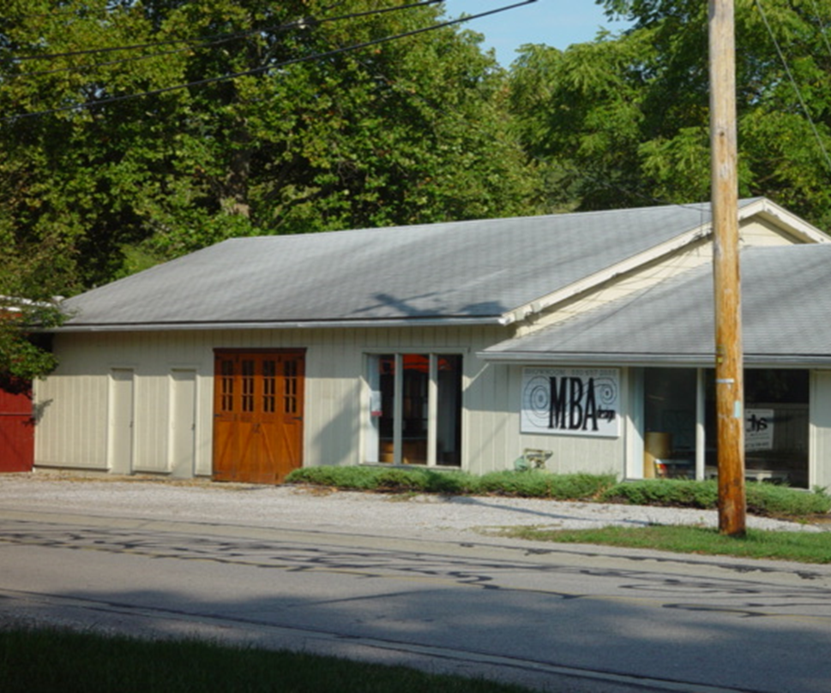

1594 Main Street - DMT Building
Summit County parcels: 11-00261 & 11-00262
Zoned: Commercial Square Footage: 2269 Year Built: 1958
Wastewater: Septic system. It may be possible to be connect it to the Foundation wastewater plant assuming OEPA approval.
Water: Hauled water system
Current Status: Property is vacant. Environmental contamination from a gasoline storage tank formerly on property. Foundation is pursuing funding for cleanup. Listed as non-contributing on the National Historic Register Peninsula Nomination.
Desired Outcome: Removal of existing building, and development of sensitively designed new two-story building on one of the most prominent locations in the Village. Retail/commercial services on first floor and commercial or residential on second floor if feasible.

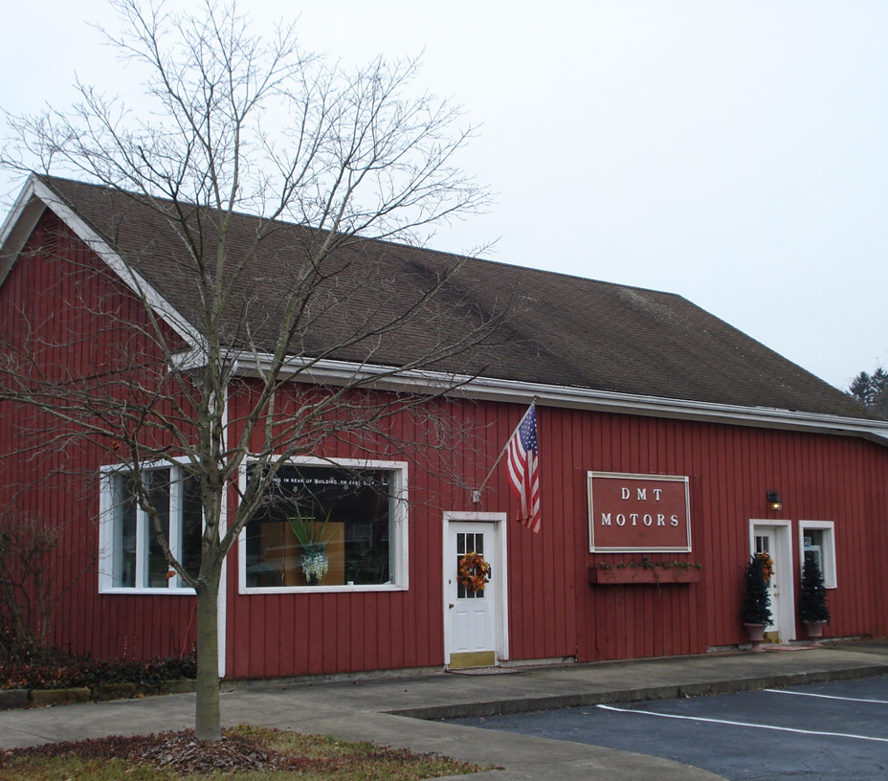

1770 Main Street - Riverview Court North
Summit County parcel: 11-00559
Zoned: Commercial Square Footage: 4619sq ft Year Built: 1927
Wastewater: Disabled septic system – needs sewage storage tank in lieu of central sewer.
Water: Needs a new hauled water system.
Current status: Building is vacant. Underground fuel storage tank will be removed. There is no indication of any leakage at this time. Shared parking lot with Riverview Court South and Bigelow House. Located across the street from the GAR Hall, which hosts 16,000 concertgoers annually. Listed as non-contributing on the National Historic Register Peninsula Nomination.
Desired Outcome: Repurpose existing building for single or multiple commercial/retail tenants. Demolition would be considered, if replaced with a new two-story building with retail/commercial services on first floor and commercial or residential on second floor, if feasible.

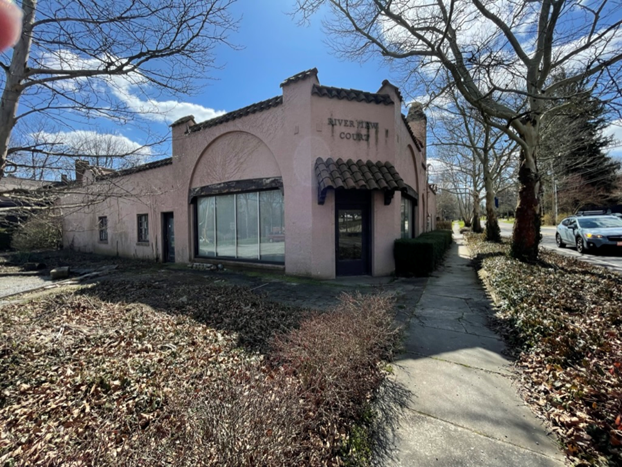

1770 Main Street - Riverview Court South
Summit County parcel: 11-00558
Zoned: Commercial Square Footage: 3696 Year Built: 1929
Wastewater: Currently shares wastewater system with Bigelow House property.
Water: Needs a new hauled water system.
Current status: Building is vacant. Shared parking lot with Riverview Court North and Bigelow House. Located across the street from the GAR Hall, which hosts 16,000 concertgoers annually. Listed as non-contributing on the National Historic Register Peninsula Nomination.
Desired Outcome: Repurpose existing building for commercial/retail tenant. Demolition of existing building would be considered, with new two-story building with commercial/retail on first floor with residential unit(s) on second floor, or multi-unit residential if feasible.

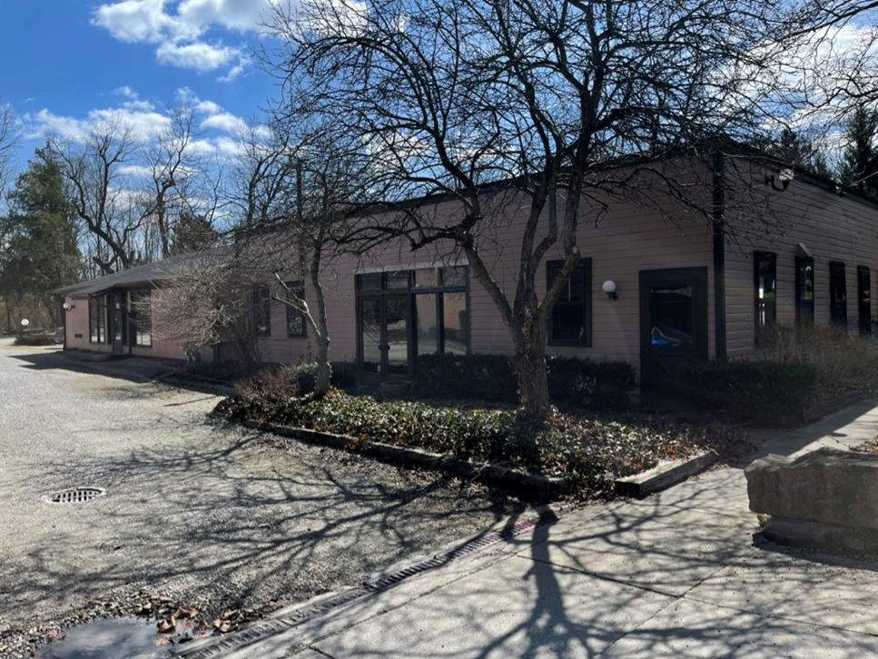

1764 Main Street – Bigelow House
Summit County parcel: 11-00560
Zoned: Commercial Square Footage: Year Built: 1870
Wastewater: Currently shares wastewater system with Riverview South property.
Water: Hauled water system
Current status: East and West residential units are rented on annual leases. Shared parking lot with Riverview Court North and South properties. Located across the street from the GAR Hall, which hosts 16,000 concertgoers annually. Listed as Contributing on the National Historic Register Peninsula Nomination.
Desired Outcome: Commercial/retail use or maintain current two-family residential use.

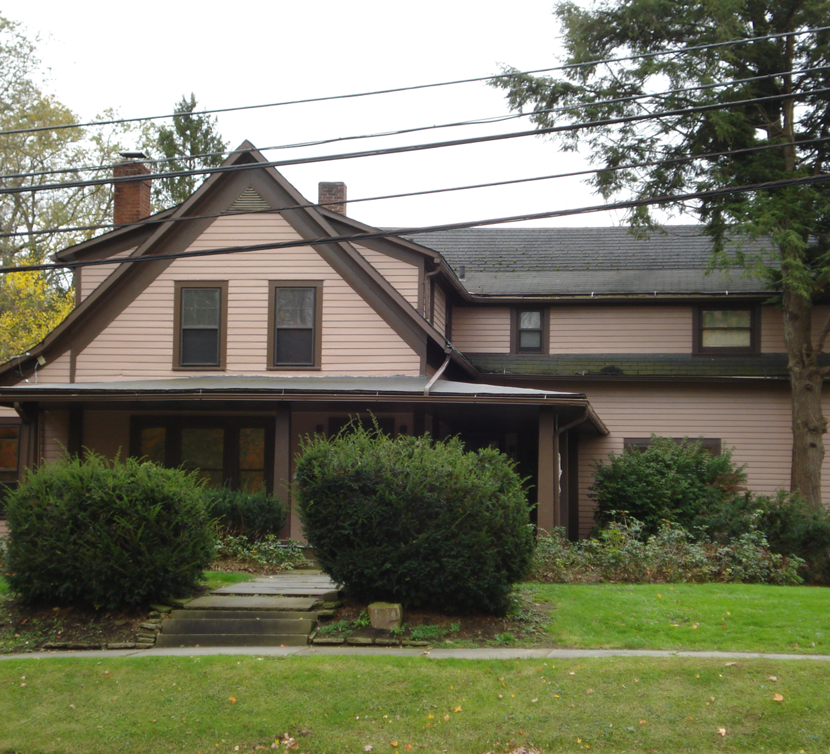

1599 Main Street – Nestico House
Summit County parcel: 11-00226
Zoned: Commercial Square Footage: 912sq ft Year Built: 1910
Wastewater: Septic system. Connection to existing Foundation-owned wastewater treatment plant may be possible subject to Ohio EPA approval.
Water: Shared well with adjoining property owned by Peninsula Properties (Winking Lizard)
Current status: Building is vacant. Listed as Contributing on the National Historic Register Peninsula Nomination.
Desired Outcome: Rehabilitation of existing building for retail/commercial services on first floor and residential on second floor if feasible. Existing building may be added onto in the rear of the building, and/or an additional new accessory building may be constructed in the rear to house residential unit(s) if feasible.

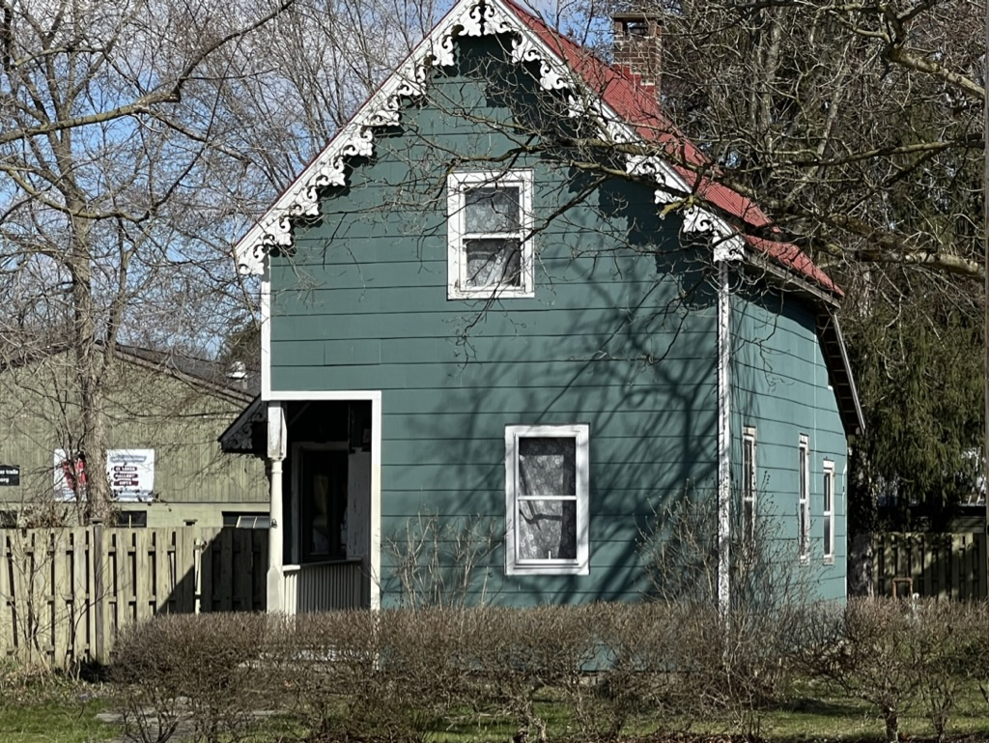

6084 N Locust St – Zolyniak House
Summit County parcel: 11-00218
Zoned: Commercial Square Footage: 1600 sq ft Year Built: 1883
Wastewater: Currently connected to the Peninsula Foundation wastewater plant.
Water: Needs a new hauled water system.
Current status: Property is currently rented and occupied as a single unit residential house on a month-to-month lease. Listed as Contributing on the National Historic Register Peninsula Nomination.
Desired Outcome: Rehabilitation of existing building for first floor retail/commercial services. Second floor could be used for retail/commercial services or maintain existing second floor residential space. Existing outbuilding could be demolished or adaptively developed for related uses.

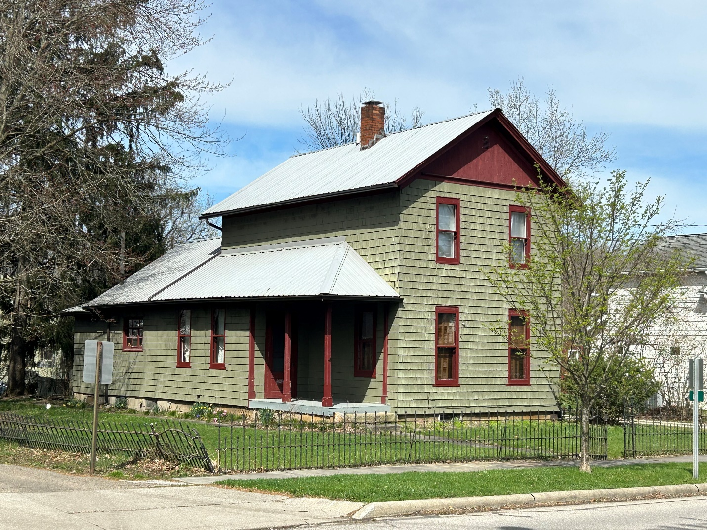

Target Audiences
The primary audience for your proposal is the Executive Director and Board of the Peninsula Foundation, who will evaluate proposals, and select one or more for further discussion and negotiation. The Foundation reserves the right to work with the proposer of its choice, or to not select any proposer for a given property.
The second audience for your proposal will be the Village of Peninsula. The goals of the Village of Peninsula’s Long-Range Plan (adopted in 2003 including recent comprehensive updates adopted by Village Council on November 11, 2019), and its companion Zoning Code, are to protect the health, safety and general welfare of the residents, institutions and businesses of the Village now and well into the future. The Purpose of the Long-Range Plan includes commitments to the conservation of the Village’s “small town” character and protection of its distinct historic character, particularly in the expanded Historic District (certified March 17, 2017 in the National Register of Historic Places), while balancing the needs of the residents and tourism so as to preserve the unique character of the “canal-era village”. The Long-Range Plan provides the framework for the development, and redevelopment, of appropriate projects in the Village, to assure an economic base that provides the necessary services for the sustainability of the community.
Chapter 1115 of the Village of Peninsula’s Zoning Code, entitled “Historic Preservation Overlay District“ (HPOD), appoints the Planning Commission as the Historic Preservation Overlay Review Board, including the duty of issuing Certificates of Appropriateness. As most of the properties offered are within the boundaries of the HPOD, any planned alterations will be assessed by the Peninsula Foundation and the Village of Peninsula Planning Commission for conformance with the United States Secretary of the Interior Standards for the Treatment of Historic Properties as a guide and criteria to assess compliance and appropriateness, as required by the Village Zoning Code.
The third audience for your proposal is the Secretary of the Interior’s Standards for Rehabilitation of Historic Properties and Illustrated Guidelines on Sustainability for Rehabilitating Historic Buildings.

Proposal Submission Requirements
There is no template format for project submission, other than all submissions shall be electronic. Each proposal should contain the following elements:
- Graphic rendering(s) of the proposed building rehabilitation or proposed new building(s) including a site plan.
- Description of the type of business(es) or other uses proposed for the property.
- Description of proposed business relationship with the Foundation.
- Description and estimated cost of proposed capital improvements provided by proposer, if applicable.
- Description and estimated cost of capital improvements provided by the Foundation, if applicable.
- Proposed funding sources for the project.
- Estimated timetable of project.
- Proposed rent schedule, if applicable.
Proposer/Developer Information
- Project Team resumes.
- Relevant professional experience and examples of similar completed projects.
- References are not required if examples of business experience and background are provided.

Miscellaneous
The Peninsula Foundation reserves the right to:
- Accept the proposal(s) which best serves the interests of the Foundation and the Village of Peninsula.
- Reject any or all proposals.
- Conduct interviews with any and/or all respondents.
- Modify, waive, or vary the terms of the RFP at any time, including and not limited to submission deadlines and proposal requirements.
- Cancel or withdraw the RFP at any time.
The respondent, by submitting a proposal, agrees that any costs it incurs in responding to this RFP or in support of activities associated with this RFP, are to be borne by respondent and are not the responsibility of the Foundation. The Foundation will incur no obligation or liability whatsoever to anyone by reason of issuance of this RFP, or action by anyone relative thereto.

Site Visits and Inspections
All onsite visits to properties listed in this RFP, including internal inspection, will be arranged through the Foundation. These may be planned in an “open house” format or upon request, subject to scheduling availability. Prospective respondents are authorized to perform external visits to properties without prior authorization if the privacy of existing tenants is respected.
Contact and Submission Information
All inquiries about this RFP should be submitted via email to Karen Walters, Executive Director, Peninsula Foundation, karen@peninsulahistory.org
All RFP responses shall be electronic and emailed to karen@peninsulahistory.org, and must be received by close of business June 30, 2023.

